EC2 instance store lab ------🡪

1. Login to aws console Management
2. Search for ec2



1. Launch instances --🡪

1. Note that we select instance type that support instance store m5ad.large

1. Here we select EBS volume type --🡪 General Purpose SSD (gp3) and note we have instance store that appears to os with name /dev/nvme0n1

1. Instance now is up and running

1. Use EC2 connect to connect to ec2 over browser.
2. lsblk --------🡪 list all block storage and the highlighted one is instance store
3. Check if instance store has file system or not

$ sudo file -s /dev/nvme1n1

Data means there is no file system set on this block device

1. Set filesystem

$ sudo mkfs -t xfs /dev/nvme1n1

1. Make mount point(entrypoint so that we can write on this block storage)

$ sudo mkdir /beta

$sudo mount /dev/nvme1n1 /beta --------🡪 mount instance store

$ lsblk

Now its time to restart ec2 instance and check if this instance store still hold data or data lost ?

Select instance ---🡪 Instance state ---🡪 Reboot instance

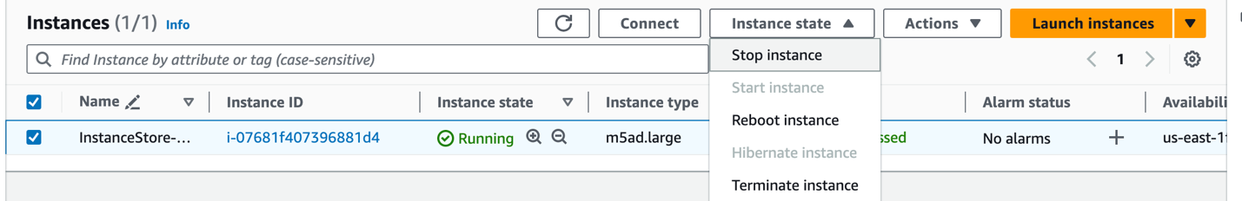

EC2 connect --🡪

Added line on /etc/fstab to persist instance store after reboot

UUID=2df18556-172f-407e-8797-ad6f2046fe50 /data xfs defaults,nofail 0 2

How to get device id ?

$ sudo blkid

Now its time to stop then start instance and check if data on instance store sill exists or not ?

Note data on instance store /dev/nvme1n1 lost after stop instance then start it again.

